**Navigating Machine Learning Deployment in Pharmaceutical Drug Safety**

**Introduction**

The pharmaceutical industry is heavily reliant on accurate decision-making, particularly when it comes to drug safety and patient health. Machine learning (ML) models have the potential to significantly accelerate processes such as adverse drug reaction prediction, but they also introduce new challenges in terms of accuracy, bias, and ethical responsibility. In the scenario at hand, a pharmaceutical company seeks to deploy an ML model with 89% accuracy to reduce costs and speed up drug approval processes. While this model is faster and cheaper than the manual process conducted by medical experts, which has 94% accuracy, the slight accuracy gap raises concerns about patient safety. Additionally, the model has revealed previously unnoticed patterns in drug interactions, presenting opportunities for innovation. This essay explores the ethical, technical, and professional considerations for deploying such a model responsibly.

* **Ethical Framework**

The primary ethical concern in deploying an ML model in healthcare is patient safety. While cost efficiency and process speed are important, they should never compromise patient well-being. As a data analyst, my professional responsibility includes ensuring that decisions based on ML outputs do not harm patients and that potential risks are transparently communicated to stakeholders. Additionally, I must ensure fairness by identifying and mitigating biases inherent in the training data, which may disproportionately affect certain demographic groups.

When facing management pressure to deploy quickly, the ethical approach is to provide a clear, evidence-based rationale for delaying deployment if necessary. This includes presenting the risks of lower accuracy, potential liability, and ethical implications of adverse events. I would advocate for a phased deployment or human-in-the-loop system that allows the model to assist, rather than replace, medical experts. This approach balances ethical responsibility with the company's desire to reduce costs and improve efficiency. Ultimately, professional ethics and patient safety must take precedence over short-term financial gains, guided by principles of transparency, accountability, and responsible innovation.

* **Technical Decision-Making**

In evaluating the deployment of a machine learning model for predicting adverse drug reactions, technical decision-making hinges on **accuracy, reliability, and fairness**. The current model demonstrates 89% accuracy, which is slightly lower than the 94% achieved by medical experts. Before recommending deployment, I would establish an **accuracy threshold** aligned with industry safety standards. For high-risk applications like drug safety, an accuracy comparable to or above the expert baseline (94%) would be ideal. If the model cannot reach this threshold, a **phased or assisted deployment** may be considered, ensuring human oversight in critical decisions.

Another key technical concern is **data bias**. Analysis of the training data revealed demographic underrepresentation, which could lead to systematic errors affecting certain patient groups. To address this, I would implement **bias mitigation strategies**, such as re-sampling underrepresented groups, using fairness-aware algorithms, and augmenting the dataset with additional diverse clinical data. Regular audits would ensure that predictions are equitable across populations.

For **model validation**, multiple layers of checks are essential. I would perform rigorous **cross-validation** to assess generalization, as well as external validation using independent datasets from different demographics or geographies. A controlled **pilot study** could evaluate real-world performance before full-scale deployment. Additionally, I would implement ongoing **monitoring** to track model drift, accuracy, and bias post-deployment. These steps not only ensure technical robustness but also provide evidence to stakeholders that the model meets safety and reliability standards.

In summary, technical decision-making in this context requires a careful balance of accuracy thresholds, bias mitigation, and multi-level validation. These measures provide confidence that the ML model can safely support medical decision-making while still offering operational efficiency and innovative insights.

* **Stakeholder Communication**

Effectively communicating the risks, benefits, and limitations of an ML model to non-technical stakeholders is critical in healthcare. In this scenario, the **accuracy gap** between the ML model (89%) and human experts (94%) must be presented clearly to executives. I would use **visual aids**, such as graphs or charts, to show the difference in prediction performance and potential patient impact. Explaining the implications in **practical, non-technical terms**—for example, “the model may misclassify 5 out of 100 patients compared to expert assessment”—helps executives understand the trade-offs without requiring technical expertise.

To address **management pressure**, I would propose **alternative deployment strategies**. Options include a **human-in-the-loop system**, where medical experts review model predictions, or a **phased pilot deployment** targeting low-risk scenarios. Both approaches maintain patient safety while demonstrating operational efficiencies and cost reduction. I would also highlight the model’s potential for innovation, emphasizing that the uncovered patterns may lead to **breakthrough insights** if further investigated.

When dealing with **disagreements with domain experts**, the key is structured collaboration. I would present model results alongside expert evaluations, inviting discussion and validation. Creating an **iterative feedback loop** allows the model to improve while respecting expert judgment. Transparent communication ensures that all stakeholders understand risks, benefits, and limitations, which is essential for **ethical decision-making** and building trust in the model’s capabilities.

* **Professional Growth**

Navigating situations where model deployment decisions involve ethical and technical trade-offs provides significant opportunities for professional growth. If my recommendation to delay or modify deployment is **overruled**, I would document my concerns formally, including the potential risks to patient safety and the rationale behind my decision. This not only maintains professional integrity but also creates a record that can inform future reviews or audits.

While the model is in production, I would continue **improving its performance** through continuous learning and monitoring. This includes retraining the model with new data, addressing emerging biases, and incorporating feedback from medical experts. Establishing performance **dashboards** and alerts ensures any degradation in accuracy or fairness is detected promptly, allowing corrective action.

From this experience, I would extract valuable **lessons** for future projects: the importance of clear communication with stakeholders, the ethical responsibility of prioritizing patient safety over cost pressures, and the need for systematic bias detection and mitigation. Additionally, I would focus on enhancing skills in ML interpretability, healthcare regulations, and collaborative decision-making. By reflecting on these experiences, I would strengthen my ability to manage complex, high-stakes analytics projects in the pharmaceutical industry responsibly.

* **Industry Context**

The pharmaceutical industry is one of the most highly regulated sectors globally, with **patient safety and regulatory compliance** forming the foundation of all operational decisions. Agencies such as the FDA (U.S. Food and Drug Administration) and EMA (European Medicines Agency) enforce stringent guidelines on clinical testing, data integrity, and adverse event reporting. Any ML model deployed for predicting drug reactions must comply with these regulations, ensuring that patient safety is never compromised for operational efficiency or cost savings.

Regulatory compliance should play a **central role** in recommending whether and how the model is deployed. This includes documenting all model assumptions, validation procedures, bias mitigation strategies, and pilot study results. Regulatory review processes may also require **explainable AI**, demonstrating that the model’s decisions can be interpreted and justified to both medical professionals and oversight authorities.

Balancing **innovation and risk management** requires careful consideration. While the model’s ability to uncover previously unknown patterns offers potential breakthroughs, these insights must be rigorously validated and tested before influencing clinical decisions. By combining innovative ML insights with robust risk mitigation and regulatory adherence, the company can safely leverage technology to enhance drug safety processes while maintaining public trust and ethical responsibility.

* **Conclusion**

Deploying a machine learning model in pharmaceutical drug safety requires balancing accuracy, patient safety, cost efficiency, and innovation. While ML offers faster insights and potential breakthroughs, ethical responsibility and regulatory compliance must guide all decisions. Through careful technical validation, bias mitigation, structured stakeholder communication, and continuous improvement, it is possible to leverage ML effectively without compromising patient health. This scenario underscores the importance of professional integrity, collaborative decision-making, and learning from high-stakes experiences to responsibly harness technology in healthcare.

* **Decision Framework**

|  |  |  |
| --- | --- | --- |
| **Step** | **Decision Criteria** | **Action / Recommendation** |
| 1 | Model Accuracy ≥ Threshold (e.g., 94%) | Approve deployment with monitoring |
| 2 | Model Accuracy < Threshold | Delay full deployment; consider pilot study or human-in-the-loop system |
| 3 | Data Bias Detected | Apply bias mitigation techniques (resampling, fairness-aware algorithms, data augmentation) |
| 4 | Model Shows Innovative Patterns | Investigate patterns through controlled studies; document findings for future improvement |
| 5 | Management Pressure | Communicate risks clearly; present alternative deployment strategies |
| 6 | Regulatory Compliance Required | Ensure full documentation, validation reports, and adherence to FDA/EMA guidelines |
| 7 | Post-Deployment Monitoring | Continuously track accuracy, bias, and drift; retrain model as needed |

* **Alternative Solutions & Recommendations**

1. Hybrid Deployment:
   * ML model suggests potential ADRs.
   * Medical experts review predictions before final decision.
2. Incremental Rollout / Pilot:
   * Deploy model in controlled environment.
   * Collect real-world performance data.
3. Data Bias Mitigation:
   * Resample or augment datasets.
   * Apply fairness metrics to monitor outputs.
4. Continuous Model Improvement:
   * Monitor false positives/negatives.
   * Retrain with updated data.

* **Flowchart Version**

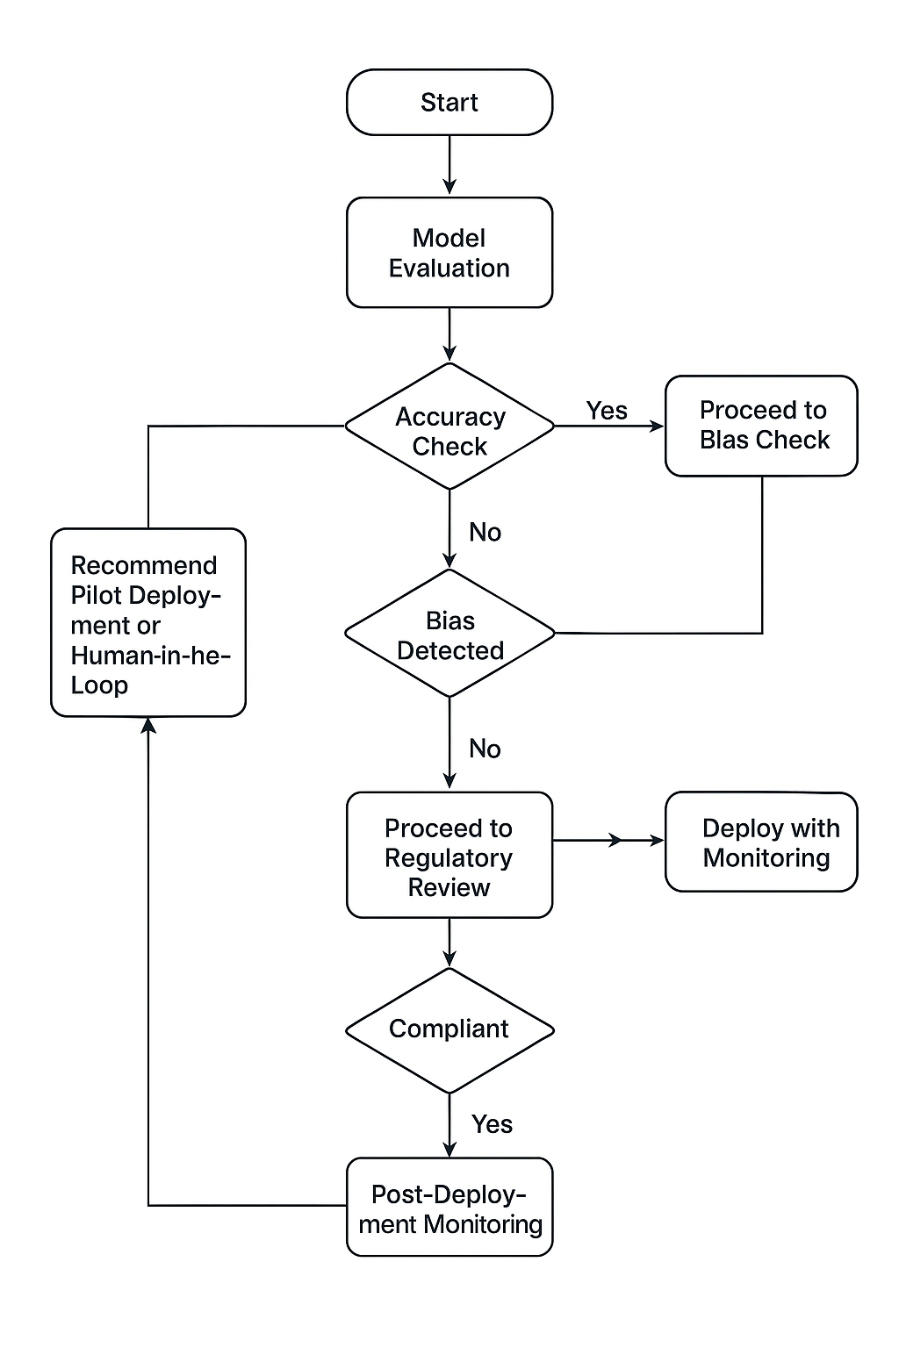

* **Ethical Framework**

Focus on patient safety, professional responsibility, and management pressure.

* Balancing Cost vs. Patient Safety:
  + Acknowledge the 10x efficiency and cost savings from your ML model.
  + Emphasize that even a 5% reduction in accuracy can affect patient safety.
  + Ethical principle: *“Do no harm”* overrides cost benefits in healthcare.
* Professional Responsibility:
  + Your role as a data analyst: ensure models are safe, unbiased, and validated.
  + Highlight the need for transparent reporting of model limitations.
* Handling Management Pressure:
  + Use clear, evidence-based communication to explain risks.
  + Offer incremental deployment or pilot programs instead of immediate full deployment.

Example Sentence Starters:

* “While deploying a model with 89% accuracy would provide significant cost and time savings, patient safety remains the highest priority.”
* “As a data professional in healthcare, I am ethically obligated to ensure that the model does not introduce unacceptable risks.”
* **Professional Development Plan**

1. **Skill Improvement**:
   * Advanced bias detection, fairness metrics.
   * Healthcare data regulations (HIPAA, FDA guidelines).
2. **Stakeholder Management**:
   * Learn to communicate complex data insights clearly to executives.
3. **Ethical Awareness**:
   * Continuous learning of ethical frameworks in healthcare AI.
4. **Innovation & Research**:
   * Track emerging ML techniques for drug safety prediction.